# DATA FLOW DIAGRAMS

# 

# Solution Architecture Diagram:

# 

# TECHNICAL ARCHITECTURE:

# 

CODING & SOLUTIONING PYTHON CODE

# import random

# file:///Users/yamini/Pictures/Photos%20Library.photoslibrary/originals/6/6013B171-8659-4D4F-AC65-7170DB528CC9.jpegprint(&#39;Hazardous Water Level=&#39;,str(random.randint(0,100))) print(&#39;Temperature=&#39;,str(random.randint(0,100))) print(&#39;Humidity=&#39;,str(random.randint(0,100))) print(&#39;Pressure=&#39;,str(random.randint(0,100)))

TESTING

# TEST CASE:

# 

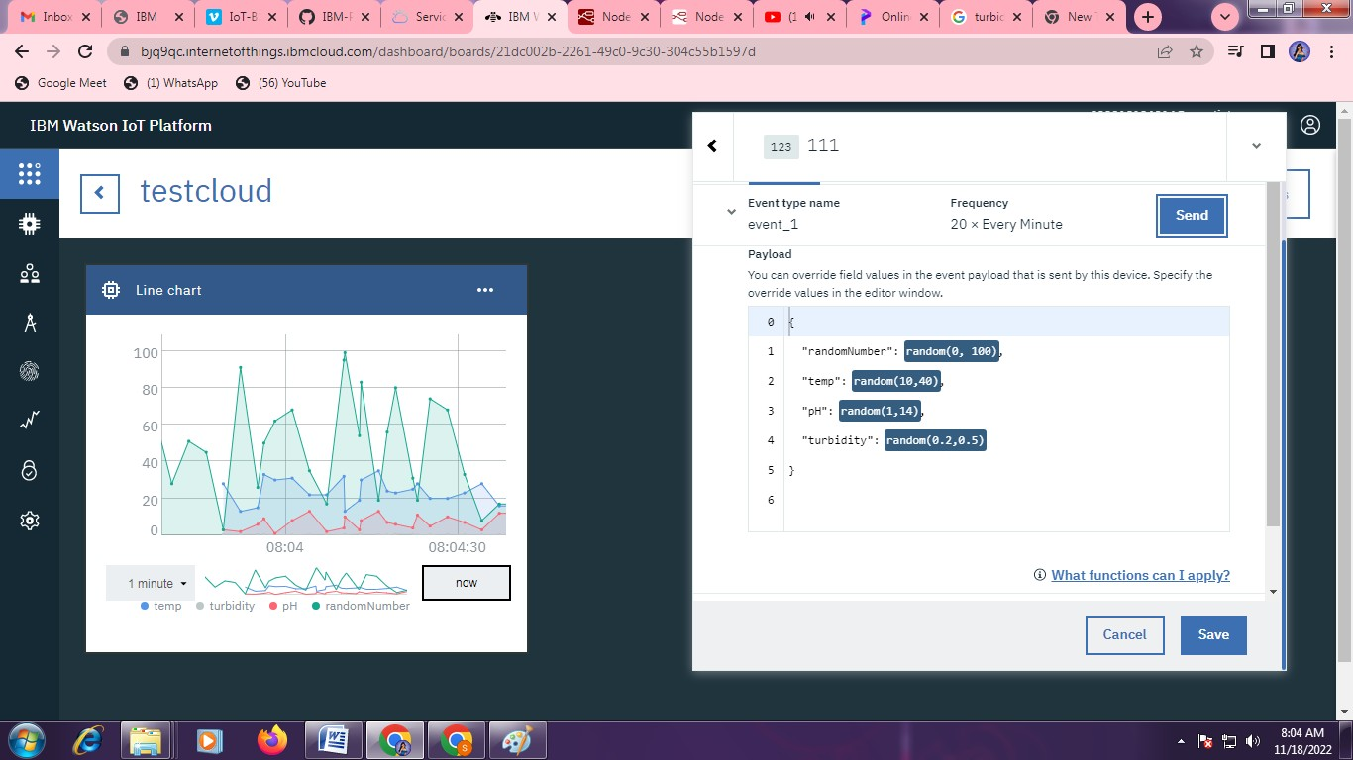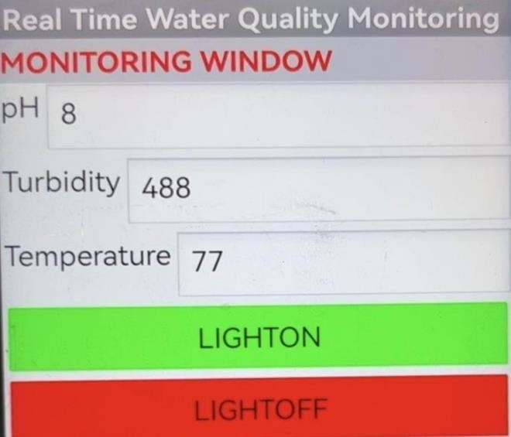

**USER ACCEPTANCE TESTING**

1. RESULTS

RESULTS:

PEFORMANCE METRICS

PH VALUE:

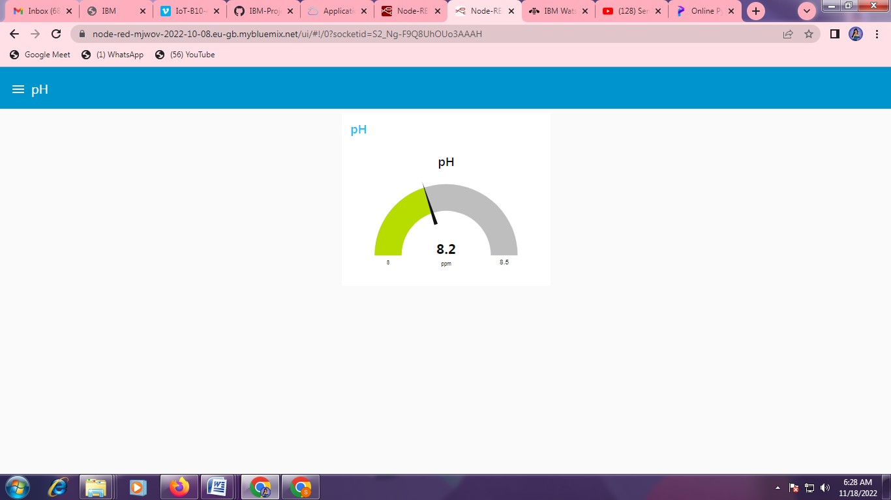

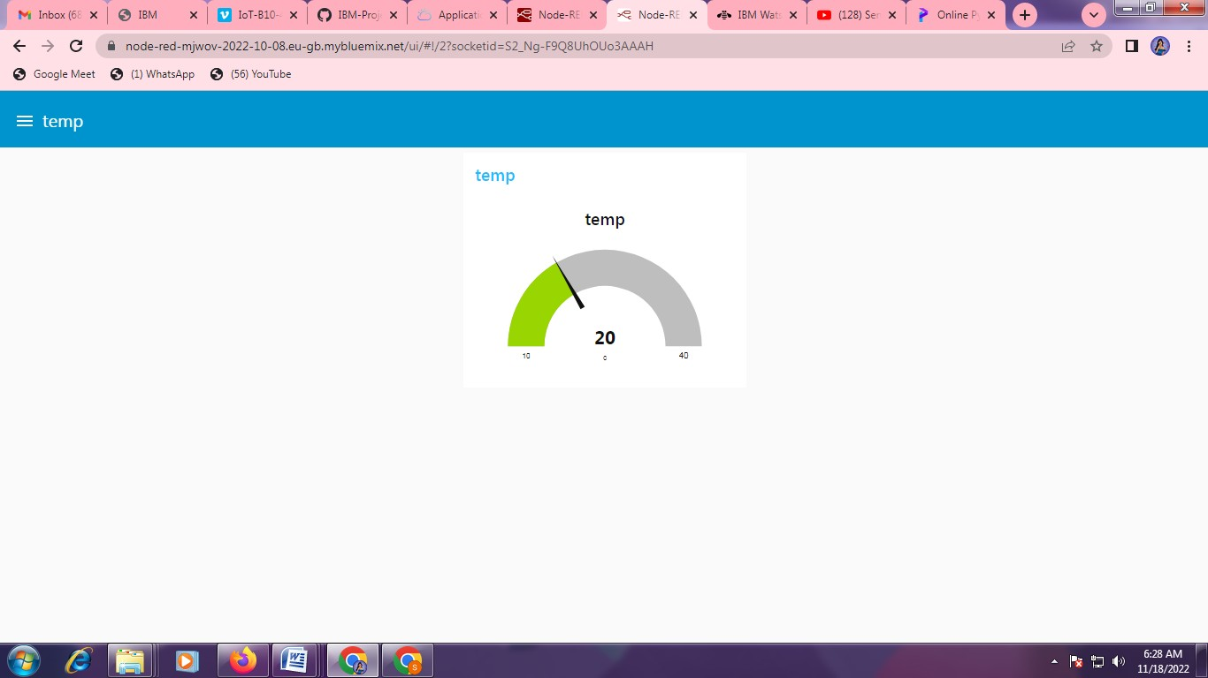**TEMP VALUE:**

# TURBIDITY VALUE:

# 